**DevOps Balachandran K K**

**22ISR005**

**Task 1**

Create a simple Freestyle Job to install Nginx on your server using Jenkins and Ubuntu VM

1. Removing Nginx from the Ubuntu terminal

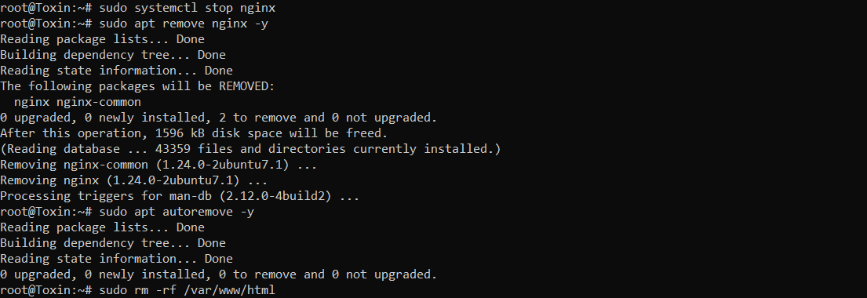

1. Now Open Jenkins and create a new task and Go to configuration and Execute shell command to install and start Nginx.

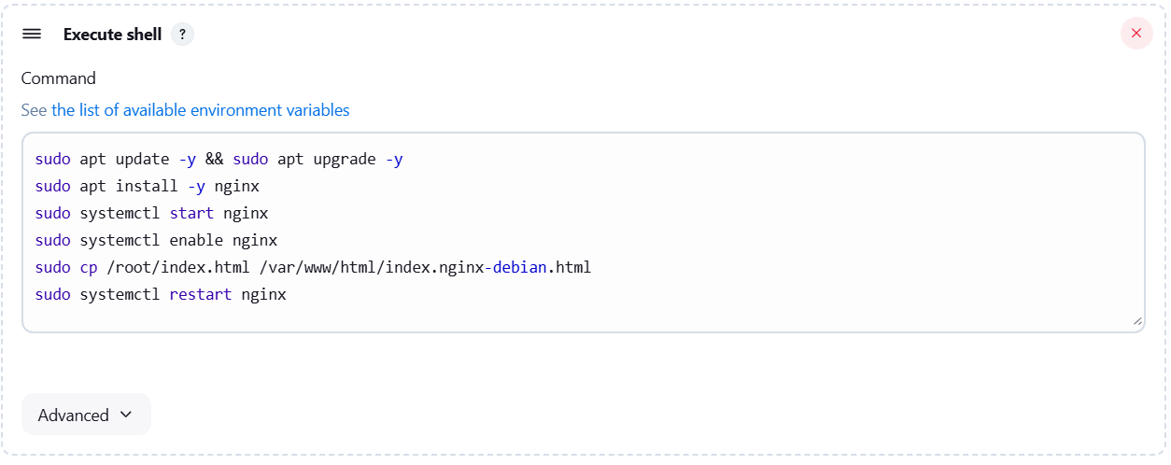

1. Installing packages of Nginx and Run the .html file in the Respective Folder.

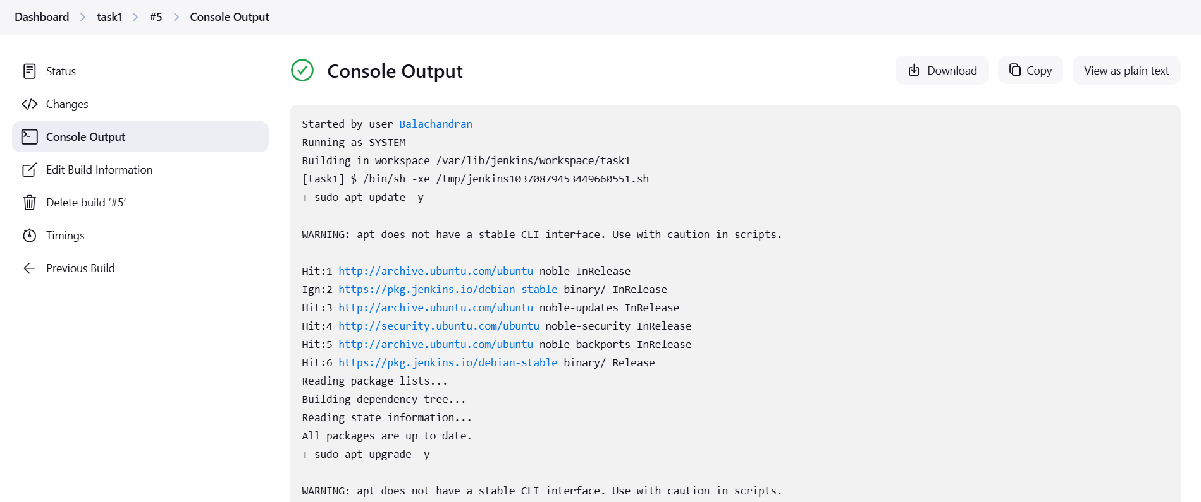

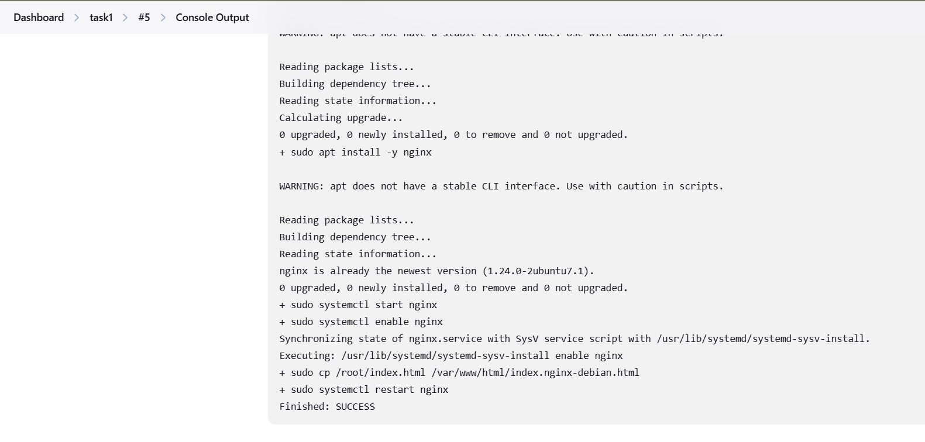

And Successfully Finished Installing and It would be run in the

<https://localhost>:80

1. Final output of the index.html in localhost : 80

